CAMP LAB-1

INTERNAL COMPONENTS OF A COMPUTER

A computer is any machine that can be programmed to carry out a set of algorithms and arithmetic instructions. The five main components that make up a typical, present-day computer include:

* A motherboard
* A Central Processing Unit (CPU)
* A Graphics Processing Unit (GPU), also known as a video card
* Random Access Memory (RAM), also known as volatile memory
* Storage: Solid State Drive (SSD) or Hard Disk Drive (HDD)

1.MOTHERBOARD

The motherboard is the body or mainframe of the computer, through which all other components [interface](http://en.wiktionary.org/wiki/interface). It is the central circuit board making up a complex electronic system. A motherboard provides the electrical connections by which the other components of the system communicate. The mother board includes many components such as: central processing unit (CPU), random access memory (RAM), firmware, and internal and external buses.

2.CENTRAL PROCESSING UNIT

The Central Processing Unit (**CPU**; sometimes just called processor) is a machine that can execute [computer programs](http://en.wikipedia.org/wiki/Computer_program). It is sometimes referred to as the brain of the computer.

There are four steps that nearly all CPUs use in their operation: *fetch*, *decode*, *execute*, and *writeback*. The first step, fetch, involves retrieving an instruction from program memory. In the decode step, the instruction is broken up into parts that have significance to other portions of the CPU. During the execute step various portions of the CPU, such as the [arithmetic logic unit](http://en.wikipedia.org/wiki/Arithmetic_logic_unit) (ALU) and the [floating point unit](http://en.wikipedia.org/wiki/Floating_point_unit) (FPU) are connected so they can perform the desired operation. The final step, writeback, simply writes back the results of the execute step to some form of memory.

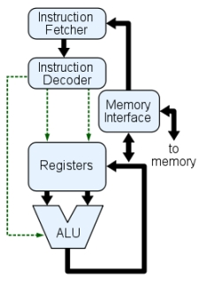

**3. The Graphics Processing Unit (GPU)**

It's not uncommon to hear gamers obsess over the next new graphics card, as these graphic cards make it possible for computers to generate high-end visuals like those found in the many [different types of video games](https://www.idtech.com/blog/different-types-of-video-game-genres).

In addition to video games, though, good graphics cards also come in handy for those who rely on images in order to execute their craft, like 3D modelers using resource-intensive software.

Graphics cards often communicate directly with the display monitor, meaning a $1,000 graphics card won't be of much use if there isn't a high-end monitor connected to it.

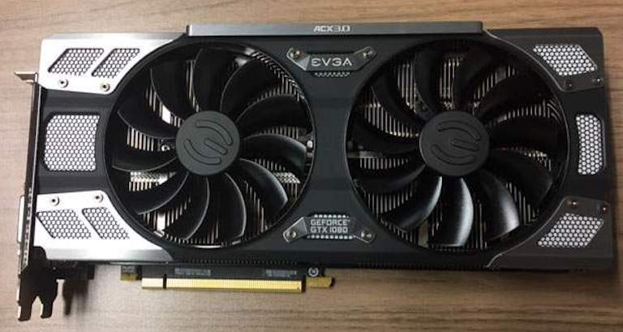

**4.Random Access Memory**

Random access memory (RAM) is fast-access memory that is cleared when the computer is power-down. RAM attaches directly to the motherboard, and is used to store programs that are currently running. RAM is a set of integrated circuits that allow the stored data to be accessed in any order (why it is called random). There are many different types of RAM. Distinctions between these different types include: writable vs. read-only, static vs. dynamic, volatile vs. non-volatile, etc.  
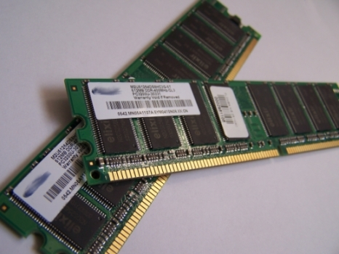

5.STORAGE

HARD DISK DRIVE

A **hard disk drive** (**HDD**), **hard disk**, **hard drive**, or fixed **disk** is an electro-mechanical data storage device that stores and retrieves digital data using magnetic storage and one or more rigid rapidly rotating platters coated with magnetic material

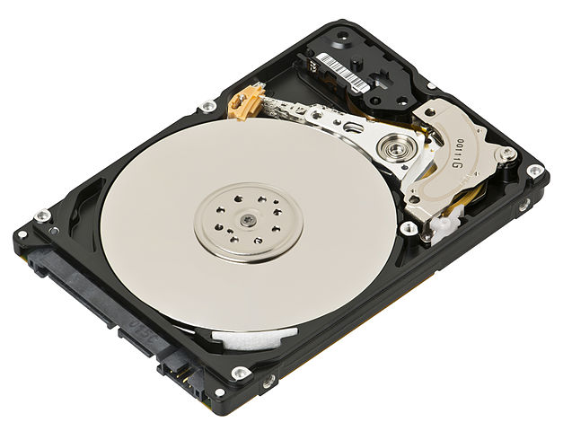

**SOLID STATE DRIVE**

**SDD**, or Solid State Drive, is one of the newest generation of storage device that's used for PCs and Laptops. In contrast to traditional Hard Disk Drives or HDD, a memory consisting of semiconductors is used to store data.

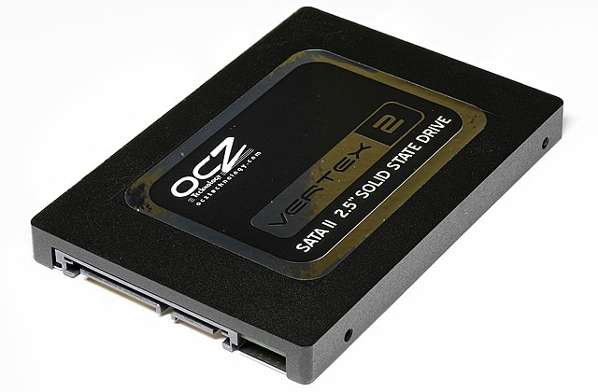

## Power Supply

True to its name, the power supply powers all other components of the machine. It usually plugs into the motherboard to power the other parts. The power supply connects to either an internal battery (on a laptop) or a plug for an outlet (on a desktop).

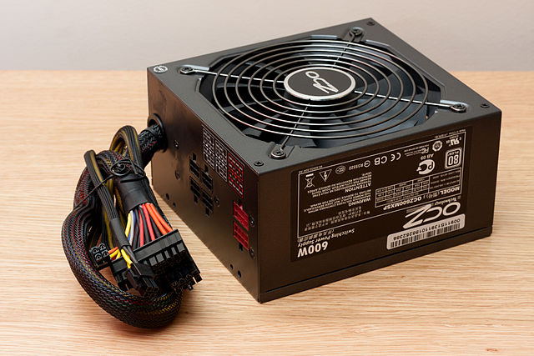

Removable Media Devices

If your putting something in your computer and taking it out is most likely a form of removable media. There are many different removable media devices. The most popular are probably CD and DVD drives which almost every computer these days has at least one of. There are some new disc drives such as Blu-ray which can hold a much larger amount of information then normal CDs or DVDs. One type of removable media which is becoming less popular is floppy disk.

### CD

CDs are the most common type of removable media. They are inexpensive but also have short life-span. There are a few different kinds of CDs. CD-ROM which stands for Compact Disc read-only memory are popularly used to distribute computer software although any type of data can be stored on them. CD-R is another variation which can only be written to once but can be read many times. CD-RW (rewritable) can be written to more than once as well as read more than once. Some other types of CDs which are not as popular include Super Audio CD (SACD), Video Compact Discs (VCD), Super Video Compact Discs (SVCD), PhotoCD, PictureCD, CD-i, and Enhanced CD.

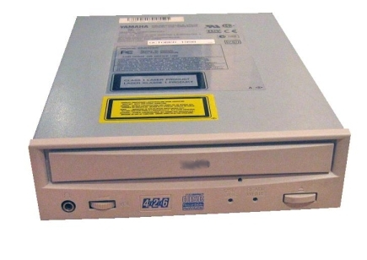

DVD

DVDs (digital versatile discs) are another popular optical disc storage media format. The main uses for DVDs are video and data storage. Most DVDs are of the same dimensions as compact discs. Just like CDs there are many different variations. DVD-ROM has data which can only be read and not written. DVD-R and DVD+R can be written once and then function as a DVD-ROM. DVD-RAM, DVD-RW, or DVD+RW hold data that can be erased and re-written multiple times. DVD-Video and DVD-Audio discs respectively refer to properly formatted and structured video and audio content. The devices that use DVDs are very similar to the devices that use CDs. There is a DVD-ROM drive as well as a DVD writer that work the same way as a CD-ROM drive and CD writer. There is also a DVD-RAM drive that reads and writes to the DVD-RAM variation of DVD.

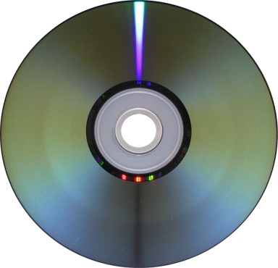

FLOPPY DISK

A floppy disk is a type of data storage that is composed of a disk of thin, flexible(“floppy”) magnetic storage medium encased in a square or rectangular plastic shell. Floppy disks are read and written by a floppy disk drive. Floppy disks are a dying and being replaced by the optical and flash drives. Many new computers do not come with floppy drives anymore but there are a lot of older ones with floppy drives lying around. While floppy disks are very cheap the amount of storage on them compared to the amount of storage for the price of flash drives makes floppy disks unreasonable to use.

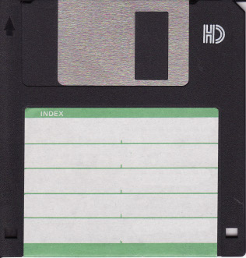

NORTH BRIDGE OF MOTHER BOARD

Northbridge is connected directly to the CPU via the [**front-side bus**](https://en.wikipedia.org/wiki/Front-side_bus) (FSB) and is thus responsible for tasks that require the highest performance. The northbridge is usually paired with a southbridge, also known as [**I/O controller hub**](https://en.wikipedia.org/wiki/I/O_Controller_Hub).

The northbridge was also named external **memory controller hub** (*MCH*) or **graphics and memory controller hub** (*GMCH*) is equipped with integrated graphics.

The overall trend in processor design has been to integrate more functions into fewer components, which decreases overall motherboard cost and improves performance. The [**memory controller**](https://en.wikipedia.org/wiki/Memory_controller), which handles communication between the CPU and RAM, was moved onto the processor [**die**](https://en.wikipedia.org/wiki/Die_(integrated_circuit)) by AMD beginning with their [**AMD64**](https://en.wikipedia.org/wiki/AMD64) processors and by Intel with their [**Nehalem**](https://en.wikipedia.org/wiki/Nehalem_(microarchitecture)) processors. One of the advantages of having the memory controller integrated on the CPU die is to reduce latency from the CPU to memory.

The northbridge plays an important part in how far a computer can be [**overclocked**](https://en.wikipedia.org/wiki/Overclocking), as its frequency is commonly used as a baseline for the CPU to establish its own operating frequency.

SOUTH BRIDGE

#### SOUTH BRIDGE

The southbridge typically implements the slower capabilities of the motherboard in a northbridge/southbridge [**chipset**](https://en.m.wikipedia.org/wiki/Chipset) computer architecture. In systems with [**Intel**](https://en.m.wikipedia.org/wiki/Intel) chipsets, the southbridge is named [**I/O Controller Hub**](https://en.m.wikipedia.org/wiki/I/O_Controller_Hub) (ICH), while [**AMD**](https://en.m.wikipedia.org/wiki/AMD) has named its southbridge [**Fusion Controller Hub**](https://en.m.wikipedia.org/wiki/Fusion_Controller_Hub) (FCH) since the introduction of its **[Fusion](https://en.m.wikipedia.org/wiki/AMD_Fusion)**[**AMD Accelerated Processing Unit**](https://en.m.wikipedia.org/wiki/AMD_Accelerated_Processing_Unit) (APU).

It’s basic functionality is to control the PCI Bus, ISA or LPC Bridge, SPI Bus, SMBus, DMA Controller, Mass Storage, Real-time Clock, BIOS, Audio. It also controls all I/O Ports of a computer.

#### THEIR IMPORTANCE

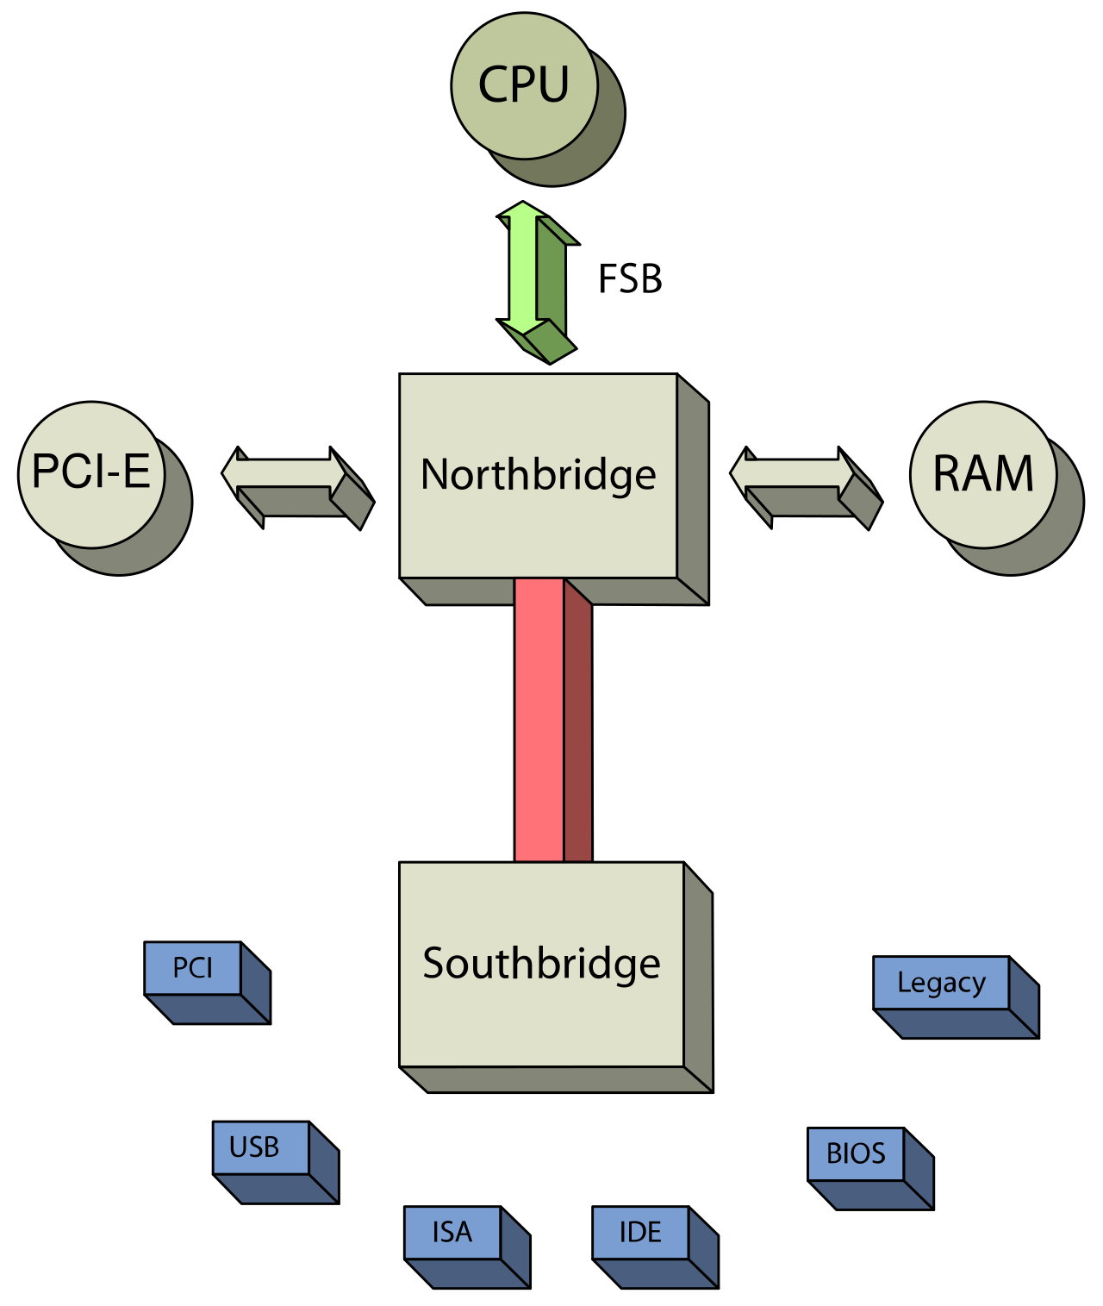

**Cache Memory** is a special very high-speed memory. It is used to speed up and synchronizing with high-speed CPU. Cache memory is costlier than main memory or disk memory but economical than CPU registers. Cache memory is an

extremely fast memory type that acts as a buffer between RAM and the CPU. It holds frequently requested data and instructions so that they are immediately available to the CPU when needed.

Cache memory is used to reduce the average time to access data from the Main memory. The cache is a smaller and faster memory which stores copies of the data from frequently used main memory locations. There are various different independent caches in a CPU, which store instructions and data.

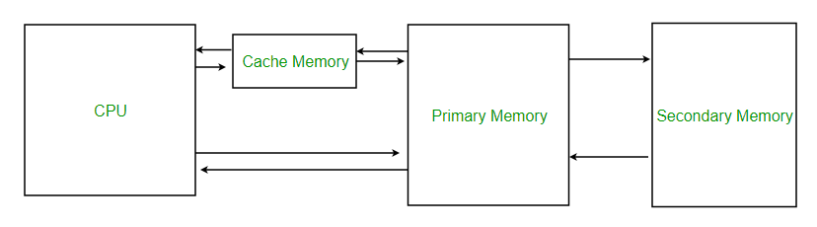

**Levels of memory:**

**Level 1 or Register**

It is a type of memory in which data is stored and accepted that are immediately stored in CPU. Most commonly used register is accumulator, Program counter, address register etc.

* **Level 2 or Cache memory –**  
  It is the fastest memory which has faster access time where data is temporarily stored for faster access.
* **Level 3 or Main Memory –**  
  It is memory on which computer works currently. It is small in size and once power is off data no longer stays in this memory.
* **Level 4 or Secondary Memory –**  
  It is external memory which is not as fast as main memory but data stays permanently in this memory.

ROM

ROM stands for **Read Only Memory**. The memory from which we can only read but cannot write on it. This type of memory is non-volatile. The information is stored permanently in such memories during manufacture. A ROM stores such instructions that are required to start a computer. This operation is referred to as **bootstrap**. ROM chips are not only used in the computer but also in other electronic items like washing machine and microwave oven.

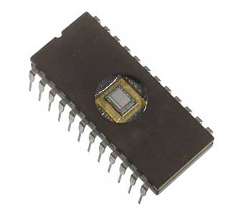

the various types of ROMs and their characteristics.

## MROM (Masked ROM)

The very first ROMs were hard-wired devices that contained a pre-programmed set of data or instructions. These kind of ROMs are known as masked ROMs, which are inexpensive.

## PROM (Programmable Read Only Memory)

PROM is read-only memory that can be modified only once by a user. The user buys a blank PROM and enters the desired contents using a PROM program. Inside the PROM chip, there are small fuses which are burnt open during programming. It can be programmed only once and is not erasable.

## EPROM (Erasable and Programmable Read Only Memory)

EPROM can be erased by exposing it to ultra-violet light for a duration of up to 40 minutes. Usually, an EPROM eraser achieves this function. During programming, an electrical charge is trapped in an insulated gate region. The charge is retained for more than 10 years because the charge has no leakage path. For erasing this charge, ultra-violet light is passed through a quartz crystal window (lid). This exposure to ultra-violet light dissipates the charge. During normal use, the quartz lid is sealed with a sticker.

## EEPROM (Electrically Erasable and Programmable Read Only Memory)

EEPROM is programmed and erased electrically. It can be erased and reprogrammed about ten thousand times. Both erasing and programming take about 4 to 10 ms (millisecond). In EEPROM, any location can be selectively erased and programmed. EEPROMs can be erased one byte at a time, rather than erasing the entire chip. Hence, the process of reprogramming is flexible but slow

## Advantages of ROM

The advantages of ROM are as follows −

* Non-volatile in nature
* Cannot be accidentally changed
* Cheaper than RAMs
* Easy to test
* More reliable than RAMs

CMOS

Stands for "Complementary Metal Oxide Semicondutor." It is a technology used to produce [integrated circuits](https://techterms.com/definition/integratedcircuit). CMOS circuits are found in several types of electronic components, including [microprocessors](https://techterms.com/definition/processor), batteries, and [digital camera](https://techterms.com/definition/digitalcamera) image sensors.

The "MOS" in CMOS refers to the [transistors](https://techterms.com/definition/transistor) in a CMOS component, called MOSFETs (metal oxide semiconductor field-effect transistors). The "metal" part of the name is a bit misleading, as modern MOSFETs often use polysilicon instead of aluminum as the conductive material. Each MOSFET includes two terminals ("source" and "drain") and a gate, which is insulated from the body of the transistor. When enough voltage is applied between the gate and body, electrons can flow between the source and drain terminals.

The "complimentary" part of CMOS refers to the two different types of semiconductors each transistor contains — N-type and P-type. N-type semiconductors have a greater concentration of electrons than holes, or places where an electron could exist. P-type semiconductors have a greater concentration of holes than electrons. These two semiconductors work together and may form [logic gates](https://techterms.com/definition/logicgate) based on how the [circuit](https://techterms.com/definition/circuit) is designed.

[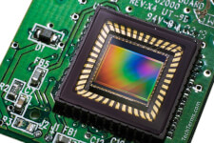](https://cdn.techterms.com/img/lg/cmos_222.jpg)CMOS image sensor